Red Team

James Brown

Joshua Frazier

Christopher McCracken

Taylor Reid

Jul 10, 2022

Module 10.3

Case study chosen: Bacchus Winery

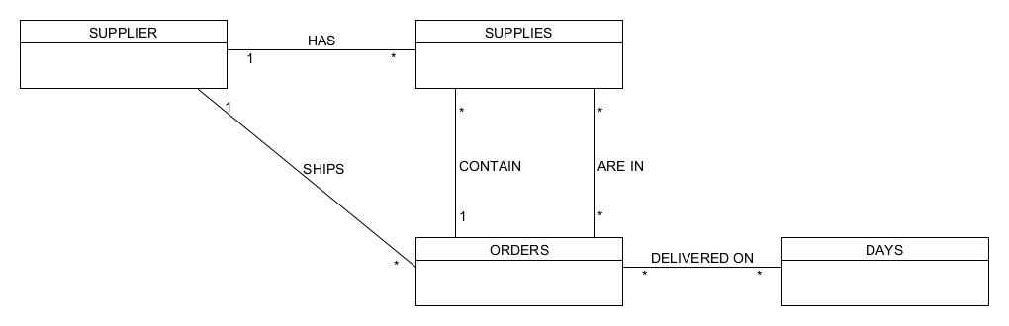(Revised) ORD:

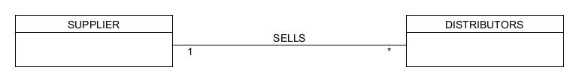

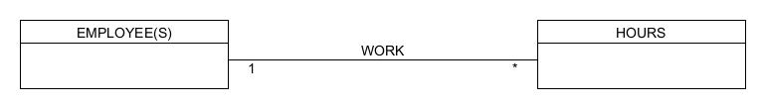

Screenshots:

